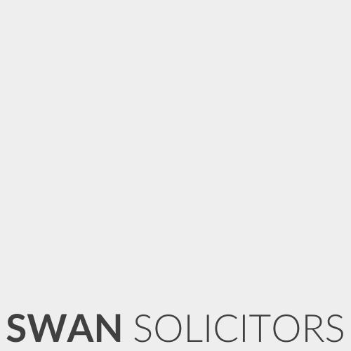

Our Ref: 01169- Washim.Mirza
Date: 06/03/2026

To the Engineer
By email only

Vehicle Inspection Instructions
Dear All

Our Client: Mr Washim Saddik Mirza
Client Address: 198A Leagrave Road, Luton, England LU3 1JD
Client Contact Tel: 07566 256077
Vehicle Reg: GX64 VEM
Vehicle Location: Please confirm vehicle location with client
Accident Date: RTA - 27/02/2026

We refer to the above matter in which we act for the Client who was involved in a road traffic accident on the above date. We kindly request that you arrange inspection of the Client’s vehicle and provide us with a copy of the same on completion.
In the report, please advise whether the vehicle is beyond economic repair, or whether it is repairable.
Please kindly note that these instructions are sent in accordance with terms and conditions as agreed between us previously, namely that the cost of the report will be paid on successful conclusion of the claim. We would ask that if the repair costs turn out to be under £150, please contact us prior to completing the report.
Kind regards

Swan Solicitors

